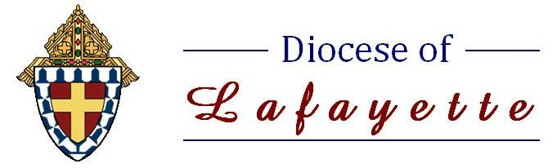


“A Safe Environment for the Protection of Children and Young People”

As part of the ongoing mission of the safety of our children here in the Diocese of Lafayette, the following information is provided to demonstrate how to access the online recertification training – Protecting God’s Children Recertification Training.

SECOND TIME ONLINE USERS ONLY: Only those individuals who have completed initial training are eligible to recertify on VIRTUS.

Important Reminder: Please review the Diocesan Code of Professional Conduct and Reporting Procedures. These documents are located under the “My Diocese” tab.

Steps to access the Protecting God’s Children Recertification Training:
- Go to www.virtus.org.
- Select in red “Need login information” and reset your user ID and Password.
- Log in using your new login information.
- Virtus will then prompt you to the “Home” page that shows “Current training” and the option to choose “Protecting God’s Children Recertification Training” (current year). This will take you to the online training session. Please allow 45 minutes to an hour to complete.

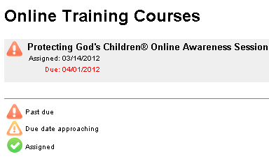

When you are logged into Virtus, you have the ability to change your account information by clicking on “Update My Account”.

For further assistance, please go to www.virtus.org and click on “Help”, then click on “VIRTUS Online Help Desk” to send a message to Virtus, or you can call 888-847-8870. You can also contact the Safe Environment Coordinator at your local church parish or school.

